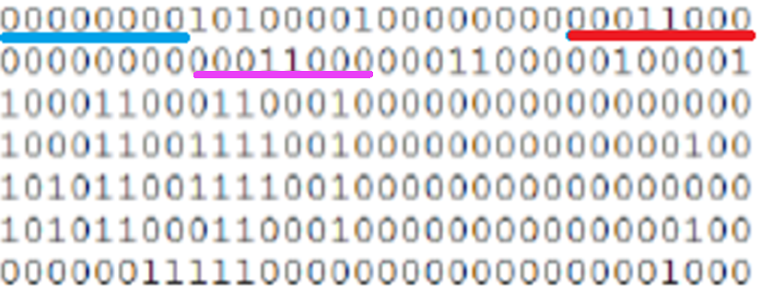

Memory (Big Endian)

|  |  |
| --- | --- |
| 低位址 | 00000000 |
|  | 10100001 |
|  | 00000000 |
|  | 00011000 |
|  | 00000000 |
|  | 00011000 |
|  |  |
| 高位址 |  |